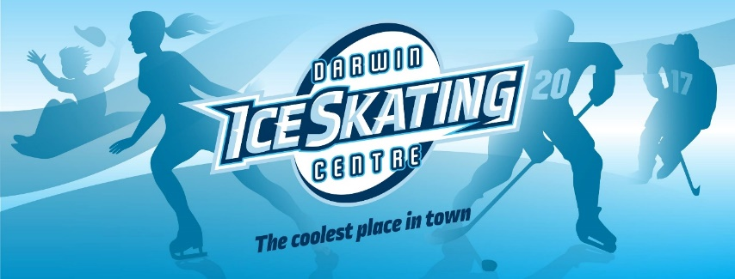

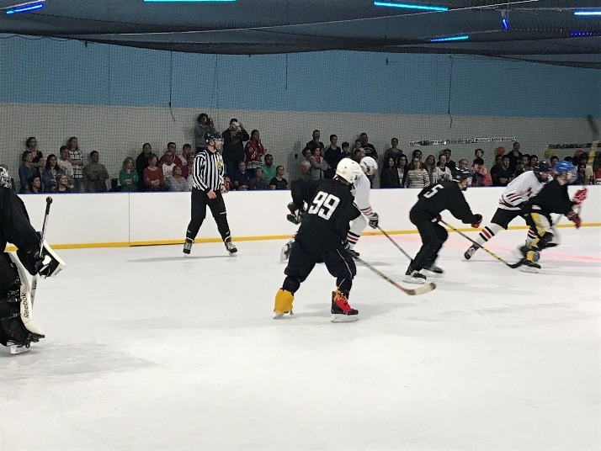 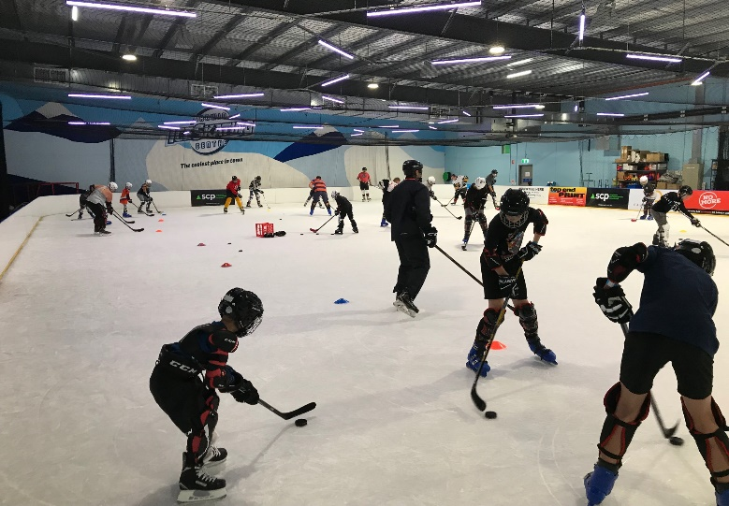

 

**LEARN2PLAY ICE HOCKEY PROGRAM**

* For beginners to existing players
* Game is fun, fast, skilful and can be played all year round out of the sun and heat
* Lessons Saturday mornings
* 7:30am to 8:45am Learn2Play Skate the Game for beginners. Focuses on getting comfortable with falling over and controlling a puck, and ice hockey skating skills such as forward skating, backward skating, crossovers, pivots, and stopping. $20 per session.
* 8:45am to 10:15am Learn2Play Play the Game. For players who have advanced from Skate the Game and are ready to enhance their puck handling and shooting skills. You will need full protective equipment for this section, which includes ice hockey drills and a development game. $30 per session.
* 10:30am to 11:30am senior drop in ice hockey game. $20 per game.
* Equipment available for hire if needed. $10
* Sports Vouchers accepted to go towards costs
* Elite and highly regarded coaches with Australia’s premier ice hockey academy

Where: Darwin Ice Skating Centre, 8 Osgood Drive, Eaton

Phone 0429 569 321 for more details. [www.darwiniceskating.com.au](http://www.darwiniceskating.com.au) File:Facebook logo (square).png Darwin Ice Skating